Chemistry 115 Name key
Dr. Cary Willard
Exam 1B February 22, 2010

 | Points Earned | Points Possible
Part 1  multiple choice |  | 30
Part 2  nomenclature |  | 10
Page 3 |  | 10
Page 4 |  | 20
Page 5 |  | 18
Page 6 |  | 12
Total |  | 100

Note: All work must be shown to receive credit. On calculation problems show answer with the correct number of significant figures using scientific notation if necessary.

Useful data:

$$K=℃+ 273.16$$
$$℉=\left(℃×1.8\right)+ 32$$
$$℃=\left(℉-32\right)/1.8$$

Part 1 – Multiple Choice (30 points)

- Why study chemistry?
  - To help inform us about our world
  - To be better able to make informed decisions
  - To better understand the properties of matter
  - To help us learn a technique for identifying and solving problems
  - All the above

- Which element is not reactive?
  - Hydrogen
  - Oxygen
  - Helium
  - Iron
  - Aluminum

- One meter is equal to

  - 0.001mm
  - 0.01cm
  - 100mm
  - 1000cm
  - 100 cm

- How many significant digits are in the number 540.2400?

  - 4
  - 5
  - 6
  - 7
  - Can not be determined

- A sample of an unknown substance was tested in a laboratory. The sample could not be decomposed by chemical or physical means. Based on these results the laboratory reported that the sample was most likely a(n)

  - Compound
  - Element
  - Solution
  - Mixture
  - Atom

- Which is not a physical property of water?
  - Water reacts with sodium metal to produce sodium hydroxide and hydrogen.
  - Water is colorless.
  - The freezing point of water is 0º Celsius.
  - The density of water at 4º C is 1.00g/mL.
  - Ice is not as hard as diamond.

- Which has both a definite shape and a definite volume?
  - solid
  - vapor
  - gas
  - liquid
  - plasma

- When expressed in proper scientific notation the number 0.000095532 is

  - 9.5532 X 10⁵
  - 9.5532 X 10^{—5}
  - 9.56 X 10⁻⁵
  - 955 X 10⁻⁷
  - 9.55 X 10⁵

- The elements on the periodic table are placed in order of increasing

  - Density
  - Boiling point
  - Atomic mass
  - Atomic number
  - Atomic size

- How many different elements are present in the compound NH₄NO₃?

  - 9
  - 5
  - 4
  - 3
  - 2

- Which of the following formulas contains the fewest oxygen atoms?

  - Ba(ClO₃)₂
  - Na₂CO₃
  - K₂Cr₂O₇
  - Ca(MnO₄)₂
  - Fe(NO₂)₂

- Which is a cation?

  - Fe⁺²
  - Cl⁻¹
  - H₂
  - Fe
  - Cl₂

- Which cannot be broken down chemically or physically into a simpler substance?

  - Sugar
  - Salt
  - Seawater
  - Copper
  - Lasagna

- Which of the following is a correctly written chemical symbol for an element on the periodic chart?

  - SN
  - Fl
  - titanium
  - ti
  - Sn

- 3.17g of sodium combines with chlorine to form 8.00g of sodium chloride. What is the mass of chlorine in this sample of sodium chloride?

  - 3.17g
  - 4.83g
  - 8.00g
  - 11.17g
  - 6.34g

Part 2 – Nomenclature (10 points)

Fill in the following chart with the correct name or formula for the following elements and compounds.

Compound / Element / Ion Name | Formula / Elemental / Ion Symbol
magnesium | Mg
iron(II) ion | Fe⁺²
Phosphorous | P
Oxide ion | O⁻²
Potassium sulfide | K₂S
Cuprous oxide | Cu₂O
Dinitrogen tetroxide | N₂O₄
Cadmium fluoride | CdF₂
Chromium(III) oxide | Cr₂O₃
Xenon hexafluoride | XeF₆

Part 3 – Problems and Questions (60 points)

- (6 points) Evaluate each of the following expressions. State the answer to the proper number of significant figures. (Be sure to round properly!)

  - $53.041+16.5+1901.22=\boxed{\begin{aligned} \\ 1970.8 \\ \end{aligned}}$

  - $\frac{\left(0.00966\right)(15.76)}{21.588}=\boxed{\begin{aligned} \\ 0.00705 \\ \end{aligned}}$

- (4 points) The ruler below is calibrated to measure centimeters. How long is the line in cm? 7.62 cm

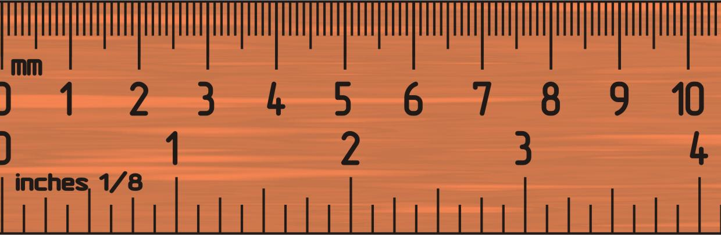
- (6 points) Round the following numbers to 3 significant figures

  - 8.49632 nm 8.50 nm

  - 83.4751 kg 83.5 kb

  - 3.8528 x 10⁻⁴ mL 3.85 x 10⁻⁴ mL

- (6 points) Complete the following metric conversions using dimensional analysis. No credit will be given without work complete with units. Give answer to the correct number of significant figures.
  - 8.46 mg to g

$$?g=8.46 mg×\frac{1 g}{1000 mg}=\boxed{8.46×{10}^{-3}g}$$

  - 96.3 cm to km

$$?km=96.3 cm×\frac{1 m}{100 cm}×\frac{1 km}{1000 m}=\boxed{9.63 ×{10}^{-4}km}$$

- (8 points) Complete the following American / metric conversions using dimensional analysis. Give answer to the correct number of significant figures (If you have forgotten a conversion factors for g to lb or cm to in, make up a number and show the correct set-up for partial credit.)

  - 8.66 kg to lb

$$?in=8.66 kg×\frac{1000 g}{1 kg}×\frac{1 lb}{454 g}= \boxed{19.1 lb}$$

  - 4.22 x 10⁻⁶ miles to nm (5280 ft = 1 mile, 1 m = 10⁹ nm)

$$?nm=4.22×{10}^{-6} mi×\frac{5280 ft}{1 mi}×\frac{12 in}{1 ft}×\frac{2.54 cm}{1 in}×\frac{1 m}{100 cm}×\frac{{10}^{9}nm}{1 m}$$
$=\boxed{6.79×{10}^{6}nm}$
- (4 points) What is the difference between a homogeneous mixture and a heterogeneous mixture?

In a homogeneous mixture all parts of the mixture are the same and have the same composition.

In a heterogeneous mixture, it is possible to see the individual components and each aliquot taken from the mixture may have a different composition

- (4 points) The mass of fuel in an airplane must be carefully accounted for before takeoff. If a 747 contains 166,000 L of fuel, what is the mass of the fuel in kilograms? The density of the fuel is 0.768 g/mL.

$$?kgfuel=166,000 L×\frac{1000 mL}{1 L}×\frac{0.768 g}{1 mL}×\frac{1 kg}{1000 g}=\boxed{127,000 kg fuel}$$

- (6 points) Iron has a density of 7.87 g/mL. If 62.4 g of iron is added to 75.0 mL of water in a graduated cylinder, to what volume reading will the water level in the cylinder rise?

$$volume in graduated cylinder=75.0 mL+7.93 mL=\boxed{82.9 mL}$$

What is the volume of the iron? (Hint: Do this part 1st)

$$?volume iron=62.4 g iron×\frac{1 mL iron}{7.87 g iron}=\boxed{7.93 mL iron}$$

- (4 points) What is the difference between a hypothesis and a theory?

A hypothesis is a tentative explanation for a process that has yet to be tested. A theory is an accepted explanation for a process which has been extensively tested and is generally accepted as being correct.
- (4 points) A solution of 18.27 g sample of sugar syrup is heated until the water has boiled off and 9.42 g of sugar remain. What percent sugar is found in the syrup?

$$?\% sugar=\left(\frac{g sugar}{g syrup}\right)×100\left(\%\right)=\left(\frac{9.42 g sugar}{18.27 g syrup}\right)×100\left(\%\right)=\boxed{51.6\% sugar}$$

- (4 points) A sample of bronze is 35.9% copper by mass. Find the mass of bronze that contains 80.0 g of copper.

$$?g bronze=80.0 g Cu×\frac{100 g bronze}{35.9 g Cu}=\boxed{223.g bronze}$$

- (4 points) The warmest temperature ever measured in the United States was 134ºF on July 10, 1913, in Death Valley, California. Convert that temperature to degrees Celsius and Kelvin.

$℉=\left(134℃×\frac{180℉}{100℃}\right)+32℉$ $K=134℃+273K$
$=241℉+32℉$ $=\boxed{407 K}$

$$=\boxed{273℉}$$

Extra credit
Why are coastal geographic regions normally cooler in the summer than inland geographic regions? (Be sure to use concepts of chemistry to answer this question.)
Water has a high specific heat and absorbs much of the heat in coastal regions therefore making the air cooler.

